TO: CIO  
FROM: Team 5  
SUBJECT: RE: Create a Captive Web Portal

A web portal has been created using Palo Alto. Palo Alto has several ways to have authenticated users access the internet.

The web portal can be setup using Palo Alto’s local database users or Active Directory. For testing purposes, it is currently using local database users as configurations needed to be completed using Active Directory.

Current User and Password for internet access is: AuthUser AuthUser

An example of the web portal is Figure 4.

This can be updated at any time and more users can be created. Main servers with critical services were have been excluded to allow internet without human interference.

It is recommended to use single sign on accounts from Active Directory to make it easier for our users.

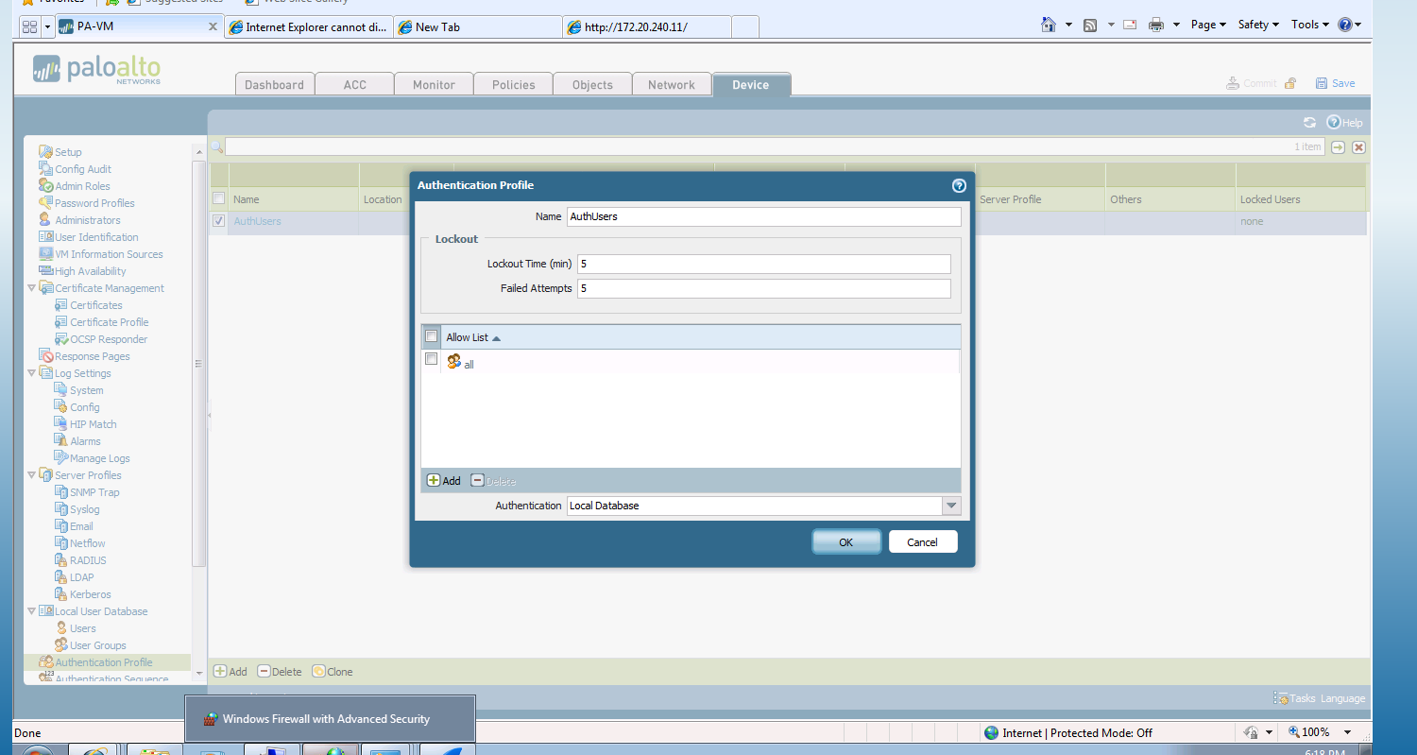

Figure 1: Setting up the Authentication Profile with Local Database

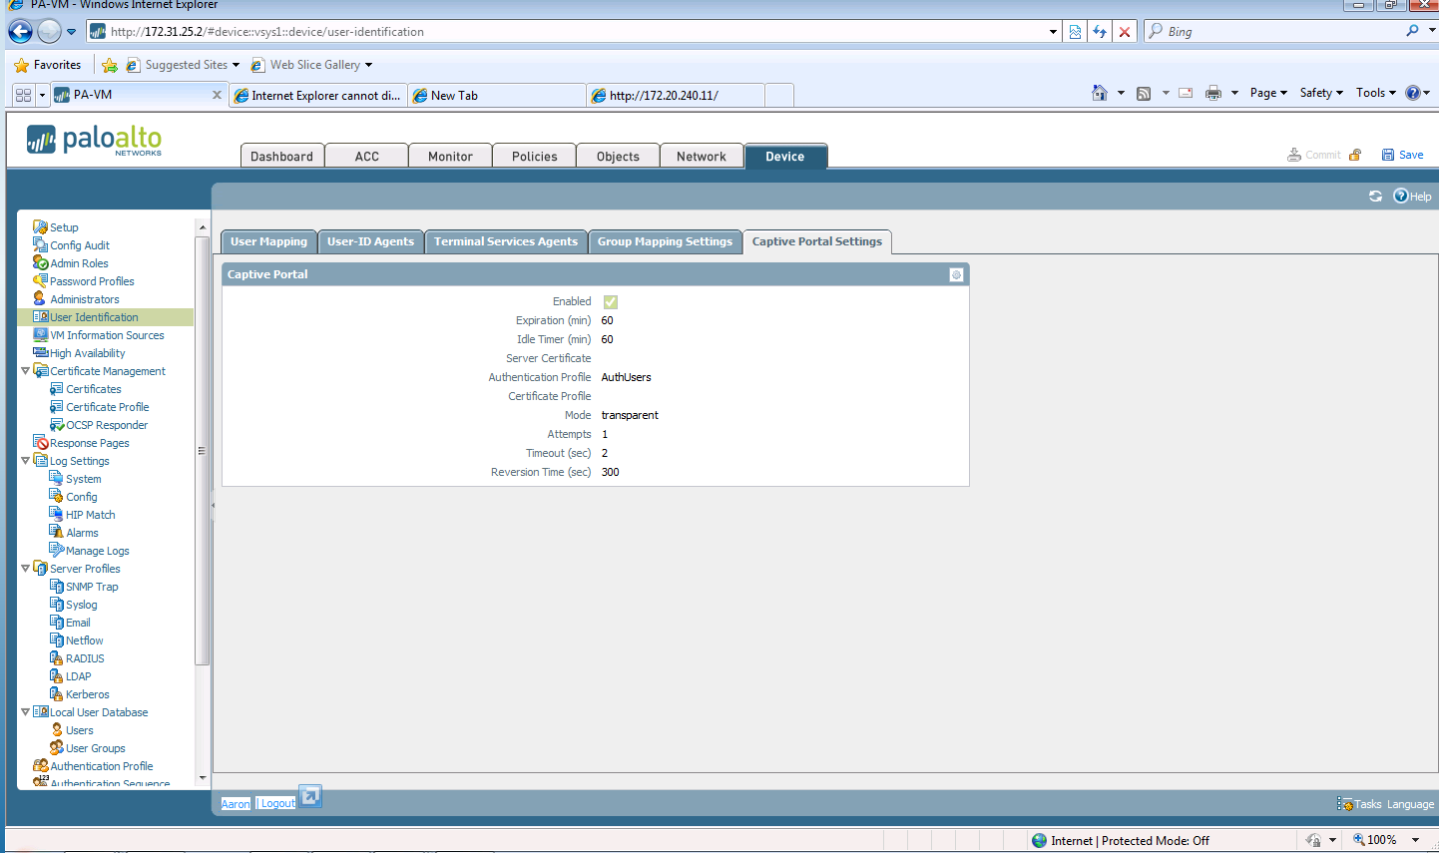

Figure 2: Setup Captive Portal Settings

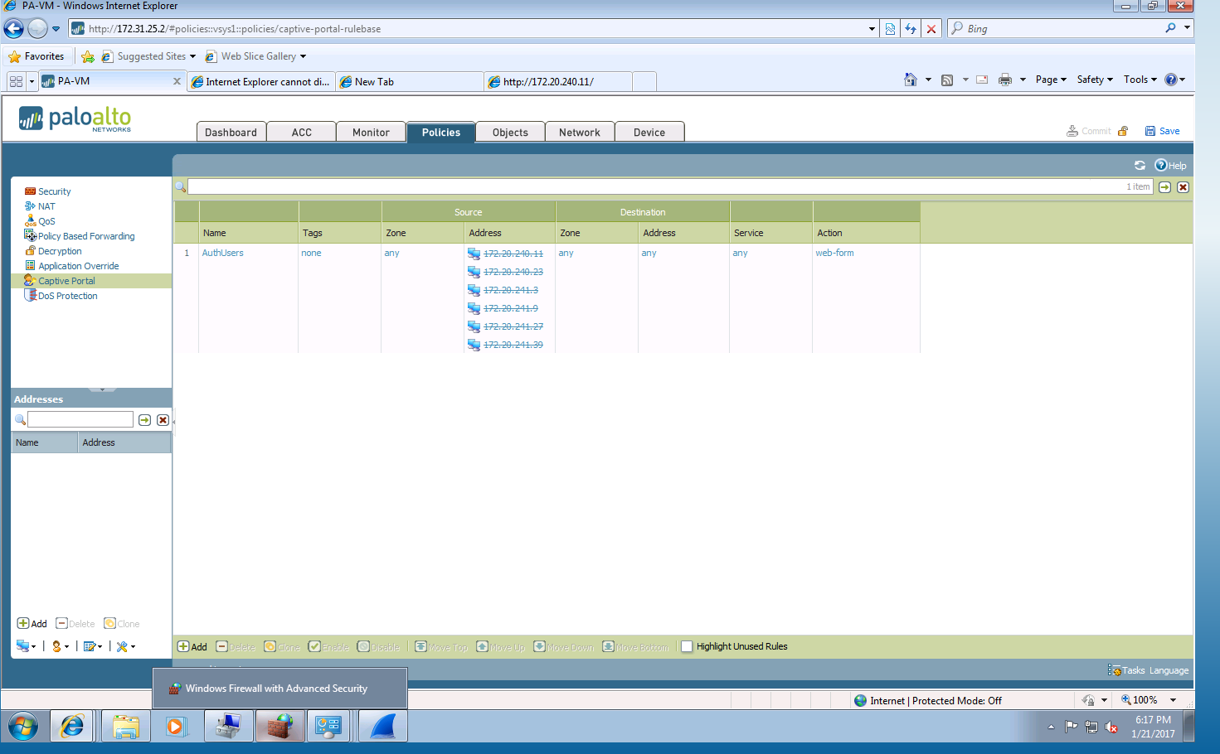

Figure 3: Add captive portal to specific zones with exception IP addresses.

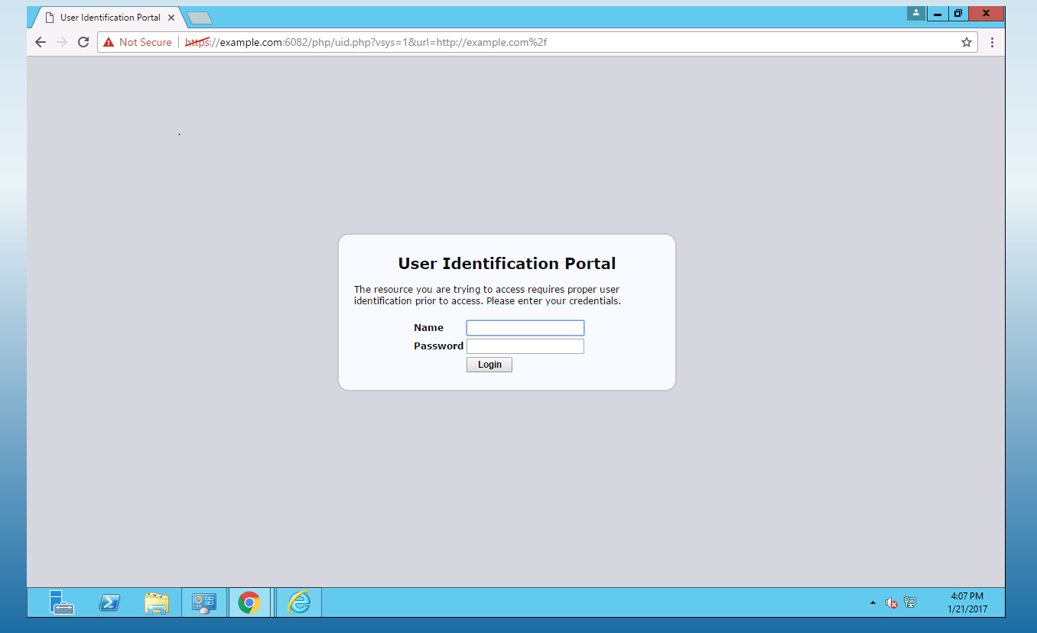

Figure 4: An example of the web portal on server 2012

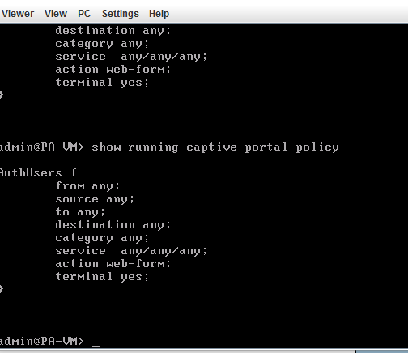

Figure 5: Proof of portal configured on Palo Alto’s CLI